

**Project Report**

**On**

**Library Management System**

**Submitted by :-**

**Sidharth Mandal.......1903002045**

**LIBRARY MANAGEMENT SYSTEM**

**Done By: Sidharth Mandal**

of VI semester BCA in the year 2022 in

partial fulfillment of the requirements for the award of Degree of

**Bachelor of Computer Application**

Sonika Anita Goyal

Project Guide Head of the Division

**ACKNOWLEDGEMENT**

We take this occasion to thank God, almighty for blessing us with his grace and taking our endeavor to a successful culmination. We extend our sincere and heartfelt thanks to our esteemed guide, Ms. Sonika, for providing us with the right guidance and advice at the crucial junctures and for showing me the right way. We also take this opportunity to express a deep sense of gratitude to our class coordinators for their cordial support, valuable suggestions and guidance. We extend our sincere thanks to our respected Head of the division Ms. Anita Goyal. We would like to thank our friends and family for the support and encouragement they have given us during the course of our work.

**TABLE OF CONTENTS**

ABSTRACT

**1. INTRODUCTION**

1.1 PROJECT AIMS AND OBJECTIVES

1.2 BACKGROUND OF PROJECT

1.3 OPERATION ENVIRONMENT

**2. SYSTEM ANALYSIS**

2.1 SOFTWARE REQUIREMENT SPECIFICATION

2.2 SOFTWARE TOOL USED

**3. SYSTEM DESIGN**

3.1 TABLE DESIGN

3.2 DATA FLOW DIAGRAM’S

**4. SYSTEM IMPLEMENTATION**

4.1 MODULE DESCRIPTION

4.2 SCREEN SHOTS

**5. SYSTEM TESTING**

5.1 UNIT TESTING

5.2 INTEGRATION TESTING

**6. CONCLUSION & FUTURE SCOPE**

**7. REFERENCES**

**Abstract:**

Library Management System is a system which maintains the information about the books present in the library, their authors, the members of library to whom books are issued, library staff and all. A library management system is software that is designed to manage all the functions of a library. It helps librarian to maintain the database of new books and the books that are borrowed by members along with their due dates. This system completely automates all your library's activities.

This computerization of library helps in many instances of its maintenances. It reduces the workload of management as most of the manual work done is reduced

**INTRODUCTION**

This chapter gives an overview about the aim, objectives, background and operation environment of the system.

⦁ PROJECT AIMS AND OBJECTIVES

The project aims and objectives that will be achieved after completion of this project are discussed in this subchapter. The aims and objectives are as follows:

⦁ Online book reading.

⦁ A search column to search availability of books.

⦁ Facility to download required book.

⦁ An Admin login page where admin can add books or page sources

⦁ Open link for Learning Websites

⦁ BACKGROUND OF PROJECT

Library Management System is an application which refers to library systems which are generally small or medium in size. It is used by librarian to manage the library using a computerized system where he/she can add new books, videos and Page sources.

Books and student maintenance modules are also included in this system which would keep track of the students using the library and also a detailed description about the books a library contains. With this computerized system there will be no loss of book record or member record which generally happens when a non-computerized system is used.

All these modules are able to help librarian to manage the library with more convenience and in a more efficient way as compared to library systems which are not computerized.

**Minimum Hardware Requirements**

|  |  |
| --- | --- |
| PROCESSOR | INTEL CORE PROCESSOR OR BETTER PERFORMANCE |
| OPERATING SYSTEM | WINDOWS VISTA, WINDOWS7, UBUNTU |
| MEMORY | 1GB RAM OR MORE |
| HARD DISK SPACE | MINIMUM 3 GB FOR DATABASE USAGE FOR  FUTURE |
| DATABASE | MY SQL |

**CHAPTER 2**

**SYSTEM ANALYSIS**

In this chapter, we will discuss and analyze about the developing process of Library Management System including software requirement specification (SRS) and comparison between existing and proposed system. The functional and nonfunctional requirements are included in SRS part to provide complete description and overview of system requirement before the developing process is carried out. Besides that, existing vs proposed provides a view of how the proposed system will be more efficient than the existing one.

⦁ SOFTWARE REQUIREMENT SPECIFICATION GENERAL DESCRIPTION

PRODUCT DESCRIPTION:

Library Management System is a computerized system which helps user(librarian) to manage the library daily activity in electronic format. It reduces the risk of paper work such as file lost, file damaged and time consuming.

It can help user to manage the transaction or record more effectively and time- saving.

PROBLEM STATEMENT:

The problem occurred before having computerized system includes:

⦁ File lost

When computerized system is not implemented file is always lost because of human environment. Some times due to some human error there may be a loss of records.

⦁ File damaged When a computerized system is not their file is always lost due to some accident like spilling of water by some member on file accidentally. Besides some natural disaster like floods or fires may also damage the files.

⦁ Difficult to search record

When there is no computerized system there is always a difficulty in searching of records if the records are large in number .

⦁ Space consuming

After the number of records become large the space for physical storage of file and records also increases if no computerized system is implemented.

⦁ Cost consuming

As there is no computerized system the to add each record paper will be needed which will increase the cost for the management of library.

⦁ SYSTEM OBJECTIVES

⦁ Improvement in control and performance

The system is developed to cope up with the current issues and problems of library

.The system can add user, validate user and is also bug free.

⦁ Save cost

After computerized system is implemented less human force will be required to maintain the library thus reducing the overall cost.

⦁ Save time

Librarian is able to search record by using few clicks of mouse and few search keywords thus saving his valuable time.

⦁ Option of online Notice board

Librarian will be able to provide a detailed description of workshops going in the college as well as in nearby colleges

⦁ Lecture Notes

Teacher has a facility to upload lectures notes in a pdf file having size not more than 10mb

**HARDWARE REQUIREMENTS**

Intel core i5 2 generation is used as a processor because it is fast than other

processors an provide reliable and stable and we can run our pc for longtime. By using this processor, we can keep on developing our project without any worries.

⦁ Ram 1 gb is used as it will provide fast reading and writing capabilities and will in turn support in processing.

Existing System:

⦁ Early days Libraries are managed manually. It required lot of time to record or to retrieve the details. The employees who have to record the details must perform their job very carefully. Even a small mistake would create a lot of problems. Security of information is very less. Report generations of all the information is very tough task.

⦁ Maintenance of Library catalogue and arrangement of the books to the catalogue is very complex task. In addition to its maintenance of member details, issue dates and return dates etc. manually is a complex task.

⦁ All the operations must be performed in perfect manner for the maintenance of the library with out any degradation which may finally result in the failure of the entire system.

Proposed System:

To solve the inconveniences as mentioned in the existing system, an Online Library is proposed. The proposed system contains the following features:

⦁ The students will register them through Online

⦁ Individually each member will have his account through which he can access the information he needs.

⦁ Book details like authors, number of copies totally maintained by library, present available number of books, reference books, non-reference books etc. all this information can be made handy.

⦁ Regarding the members designation, number of books was issued.

⦁ Issue dates and returns of each member is maintained separately and fine charged if there is any delay in returning the book.

⦁ Administrator can add, update the books.

⦁ Time consuming is low, gives accurate results, reliability can be improved with the help of security.

⦁ SOFTWARE TOOLS USED

The whole Project is divided in two parts the front end and theback end.

⦁ Front end

The front end is designed using of html , Php ,CSS, Java script

**HTML**- HTML or Hyper Text Markup Languageis the main markup language for creating web pages and other information that can be displayed in a web browser.HTML is written in the form of HTML elements consisting of tags enclosed in angle brackets (like <html>), within the web page content. HTML tags most commonly come in pairs like <h1> and </h1>, although some tags represent empty elements and so are unpaired, for example <img>. The first tag in a pair is the start tag, and the second tag is the end tag (they are also called opening tags and closing tags). In between these tags web designers can add text, further tags, comments and other types of text-based content. The purpose of a web browser is to read HTML documents and compose them into visible or audible web pages. The browser does not display the HTML tags, but uses the tags to interpret the content of the page.HTML elements form the building blocks of all websites. HTML allows images and objects to be embedded and can be used to create interactive forms. It provides a means to create structured documents by denoting structural semantics for text such as headings, paragraphs, lists, links, quotes and other items. It can embed scripts written in languages such as JavaScript which affect the behavior of HTML web pages.

**CSS**- Cascading Style Sheets (CSS) is a style sheet language used for describing the look and formatting of a document written in a markup language. While most often used to style web pages and interfaces written in HTML and XHTML, the language can be applied to any kind of XML document, including plain XML, SVG and XUL. CSS is a cornerstone specification of the web and almost all web pages use CSS style sheets to describe their presentation.CSS is designed primarily to enable the separation of document content from document presentation, including elements such as the layout, colors, and fonts. This separation can improve content accessibility, provide more flexibility and control in the specification of presentation characteristics, enable multiple pages to share formatting, and reduce complexity and repetition in the structural content (such as by allowing for table less web design).CSS can also allow the same markup page to be presented in different styles for different rendering methods, such as on-screen, in print, by voice .when read out by a speech-based browser or screen reader) and on Braille-based, tactile devices. It can also be used to allow the web page to display differently depending on the screen size or device on which it is being viewed. While the author of a document typically links that document to a CSS file, readers can use a different style sheet, perhaps one on their own computer, to override the one the author has specified. However if the author or the reader did not link the document to a specific style sheet the default style of the browser will be applied.CSS specifies a priority scheme to determine which style rules apply if more than one rule matches against a particular element. In this so-called cascade, priorities or weights are calculated and assigned to rules, so that the results are predictable.

**JAVA SCRIPT**- JavaScript (JS) is a dynamic computer programming language. It is most commonly used as part of web browsers, whose implementations allow client- side scripts to interact with the user, control the browser, communicate asynchronously, and alter the document content that is displayed. It is also being used in server-side programming, game development and the creation of desktop and mobile applications. JavaScript is a prototype-based scripting language with dynamic typing and has first-class functions. Its syntax was influenced by C. JavaScript copies many names and naming conventions from Java, but the two languages are otherwise unrelated and have very different semantics. The key design principles within JavaScript are taken from the Self and Scheme programming languages. It is a multi- paradigm language, supporting object-oriented, imperative, and functional programming styles. The application of JavaScript to use outside of web pages—for example, in PDF documents, site-specific browsers, and desktop widgets—is also significant. Newer and faster JavaScript VMs and platforms built upon them (notably Node.js) have also increased the popularity of JavaScript for server-side web applications. On the client side, JavaScript was traditionally implemented as an interpreted language but just-in-time compilation is now performed by recent (post-2012) browsers.

**MYSQL**- MySQL ("My S-Q-L", officially, but also called "My Sequel") is (as of July 2013) the world's second most widely used open-source relational database management system (RDBMS). It is named after co-founder Michael Wideners daughter, My. The SQL phrase stands for Structured Query Language. The MySQL development project has made its source code available under the terms of the GNU General Public License, as well as under a variety of proprietary agreements. MySQL was owned and sponsored by a single for-profit firm, the Swedish company MySQL AB, now owned by Oracle Corporation. MySQL is a popular choice of database for use in web applications, and is a central component of the widely used LAMP open source web application software stack (and other 'AMP' stacks). LAMP is an acronym for "Linux, Apache, MySQL, Perl/PHP/Python." Free-software-open source projects that require a full-featured database management system often use MySQL. For commercial use, several paid editions are available, and offer additional functionality. Applications which use MySQL databases include: TYPO3, MODx, Joomla, WordPress, Drupal and other software. MySQL is also used in many high-profile, large-scale websites, including Wikipedia, Google (though not for searches), Facebook, Twitter, Flickr, and YouTube

**CHAPTER 3**

**SYSTEM DESIGN**

**⦁ TABLE DESIGN**

VARIOUS TABELS TO MAINTAIN INFORMATION

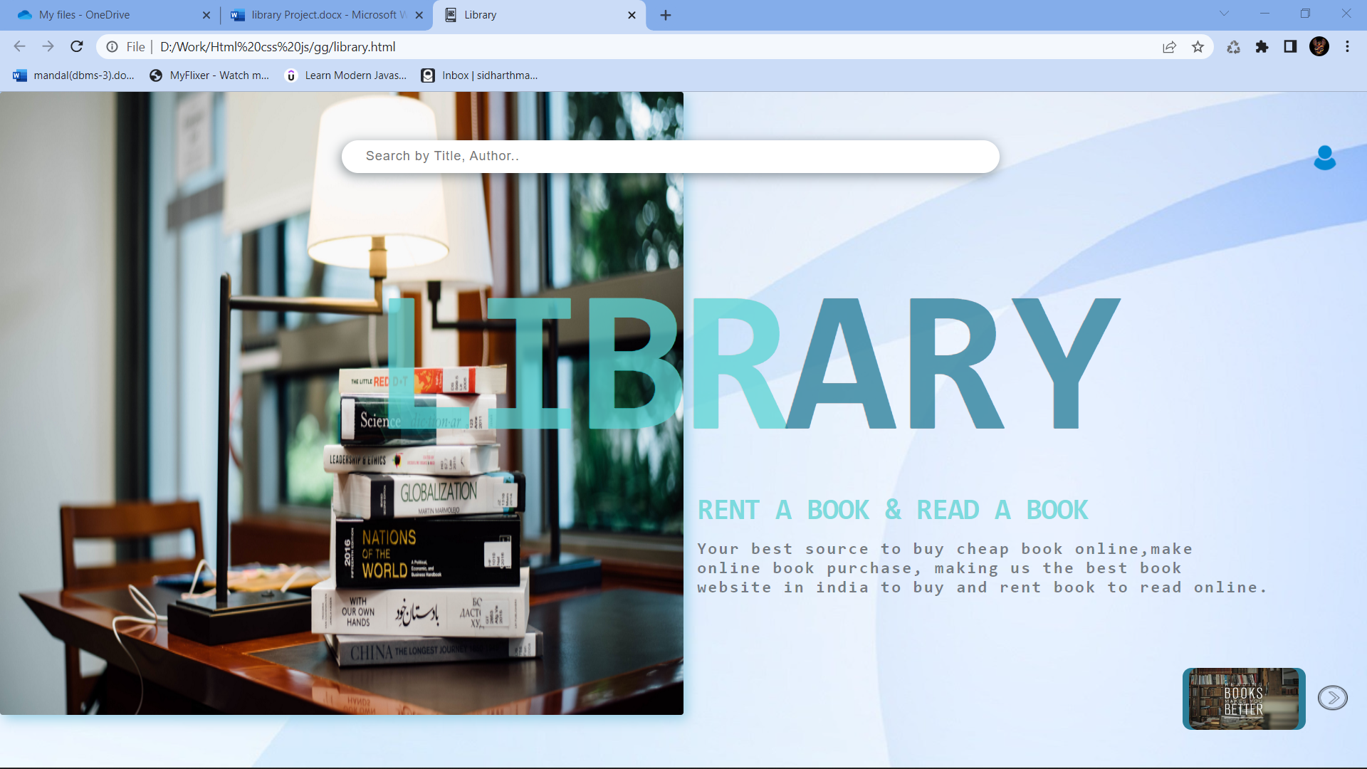

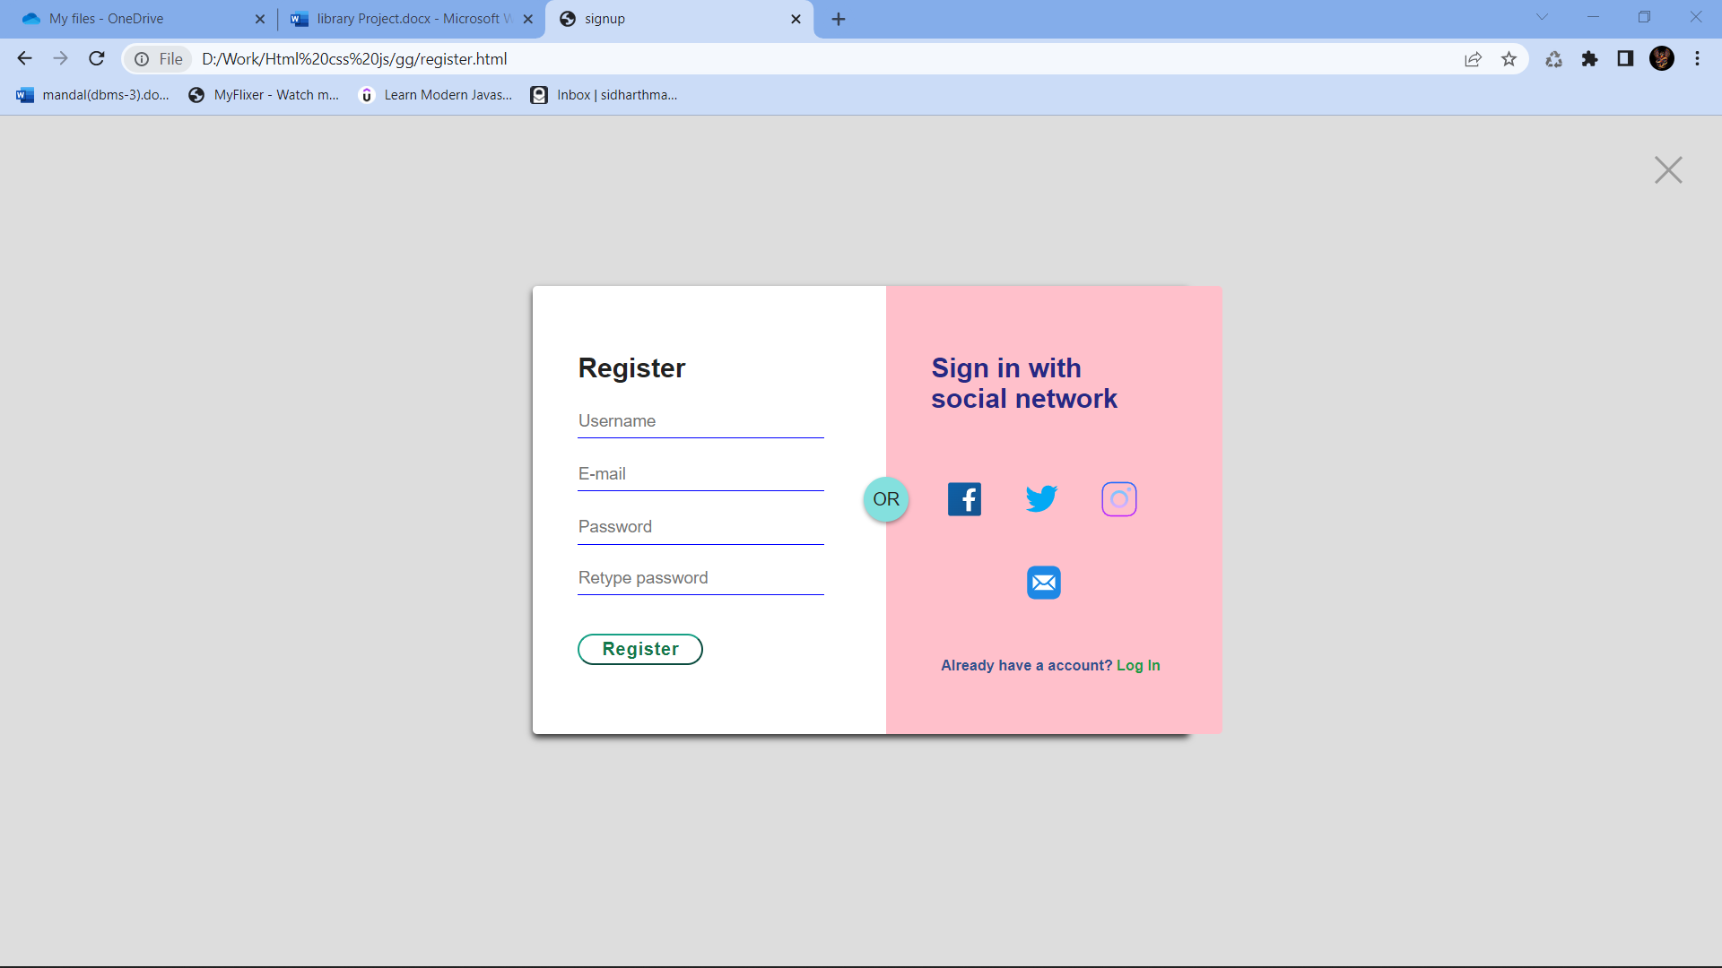

**DATA FLOW DIAGRAMS**

**USE CAESE DIAGRAM FOR USER**

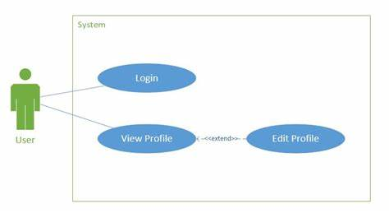

After entering to the home page of the website, Admin can choose the Admin Login option where they are asked to enter username & password and if he/she is a valid user then a teacher login page will be displayed.

**USER CASE DIAGRAM FOR ADMIN**

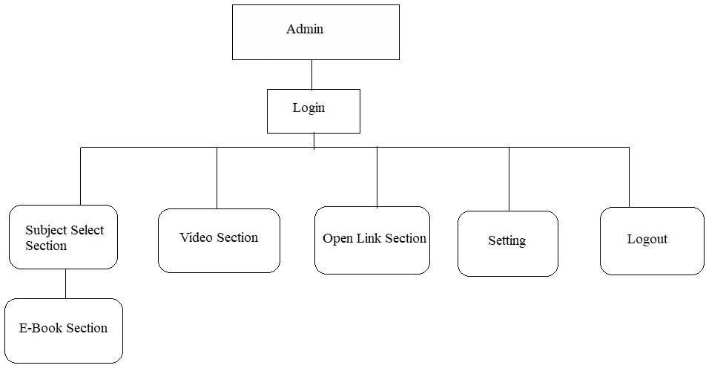

**Chapter 4**

**System implementation**

**Screenshot for all webpage. HOMPAGE**



**REGISTER PAGE...**



LOGIN PAGE....

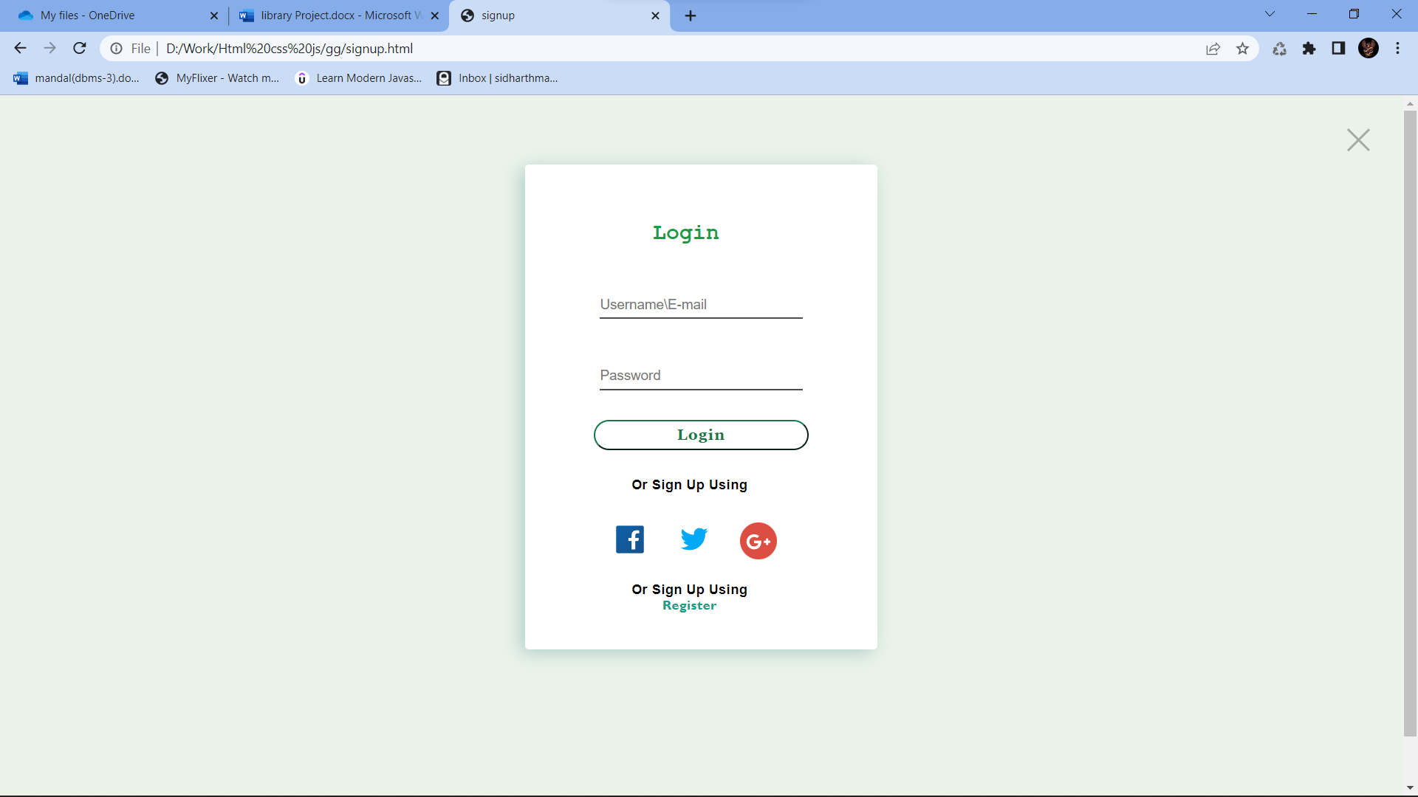

User Data...

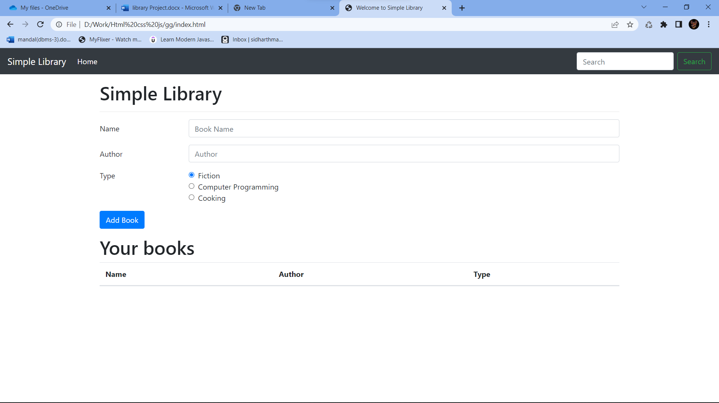

**MODULE DESCRIPTION**

For Library Management System it is divided into the following Modules describe in chapter 5.

**CHAPTER 5**

**SYSTEM TESTING**

The aim of the system testing process was to determine all defects in our project. The program was subjected to a set of test inputs and various observations were made and based on these observations it will be decided whether the program behaves as expected or not. Our Project went through two levels of testing

1.Unit testing

2.integration testing

## **UNIT TESTING**

Unit testing is undertaken when a module has been created and successfully reviewed. In order to test a single module we need to provide a complete environment ie besides the module we would require

* + The procedures belonging to other modules that the module under test calls
  + Non local data structures that module accesses
  + A procedure to call the functions of the module under test with appropriate parameters

## 

## **INTEGRATION TESTING**

In this type of testing, we test various integration of the project module by providing the input. The primary objective is to test the module interfaces in order to ensure that no errors are occurring when one module invokes the other module

**CHAPTER 6**

**CONCLUSION & FUTURE SCOPE**

This website provides a computerized version of library management system which will benefit the students as well as the staff of the library.

It makes entire process online where student can search books, staff can generate reports and do book transactions. It also has a facility for student login where student can login and can see status of books issued as well request for book or give some suggestions. It has a facility of teacher’s login where teachers can add lectures notes and also give necessary suggestion to library and also add info about workshops or events happening in our college or nearby college in the online notice board. There is a future scope of this facility that many more features such as online lectures video tutorials can be added by teachers as well as online assignments submission facility, a feature of group chat where students can discuss various issues of engineering can be added to this project thus making it more interactive more user friendly and project which fulfills each user need in the best way possible.

**CHAPTER 7**

**REFERENCES**

h[ttp://www.w3schools.com/html/html_intro.asp](http://www.w3schools.com/html/html_intro.asp)

[http://www.Udemy.com/css/css_background.asp](http://www.udemy.com/css/css_background.asp) <http://www.w3schools.com/js/js_datatypes.asp>